May 20, 2025

**N2 Generator Annual Maintenance**

Remove top, side, then back panels

Vent by turning red valve 90 degrees in top center

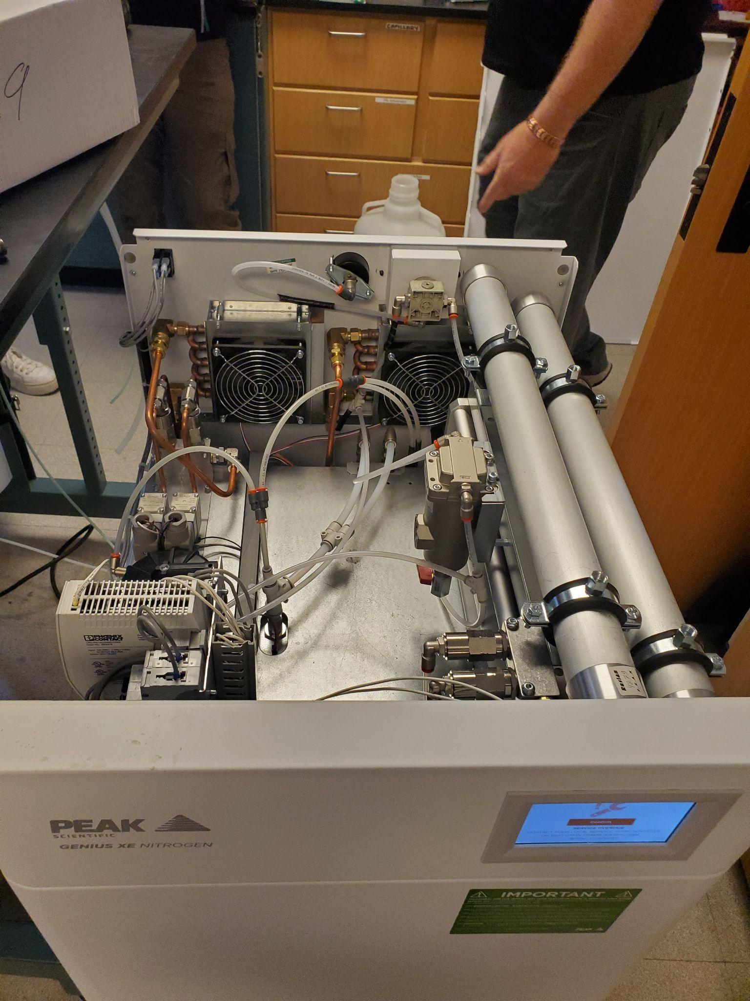

Replace filters and O rings in 3 filter bowls in bottom front. Make sure to use the right filter in right bowl. Warning, strip easily. Make sure lined up properly.

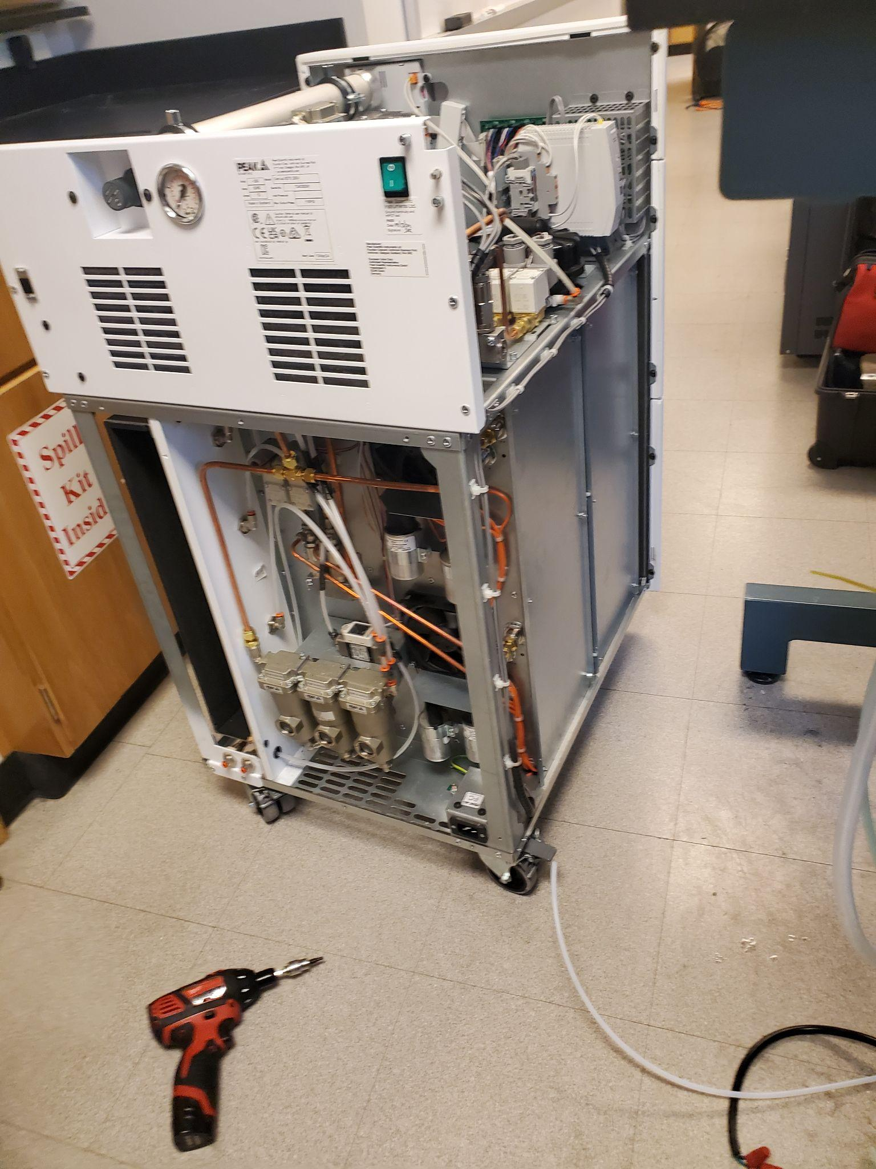

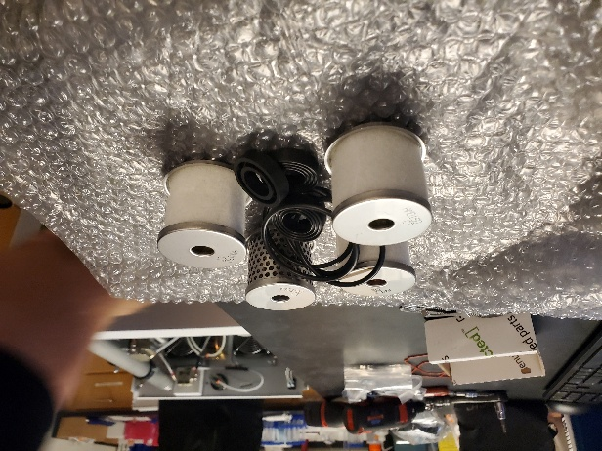

Replace filter and o rings in 4th filter bowl on top center (with the red valve)

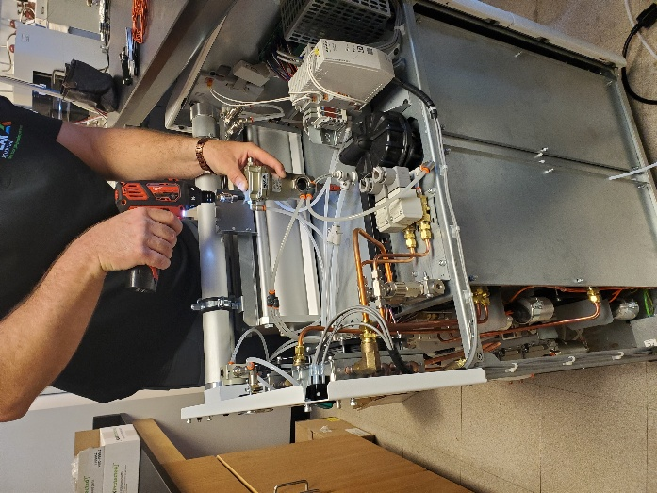

Replace carbon sock on side, and o ring, reattach

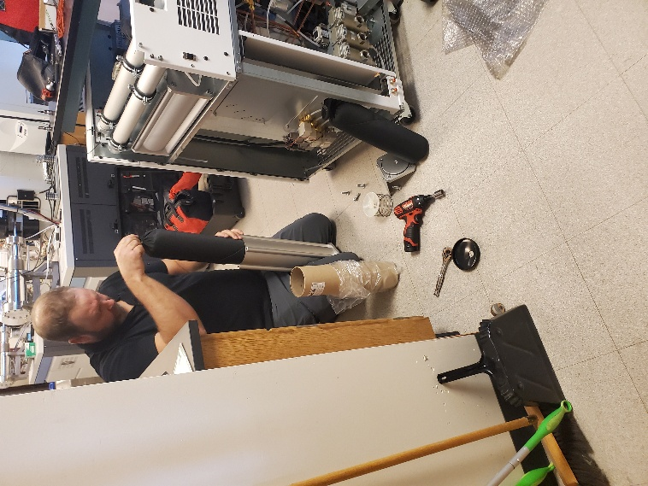

Replace inlet filter on top (black container)

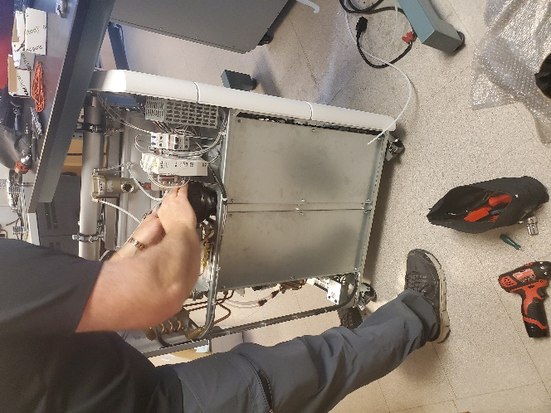

Remove 2 silver panels on side to access compressors

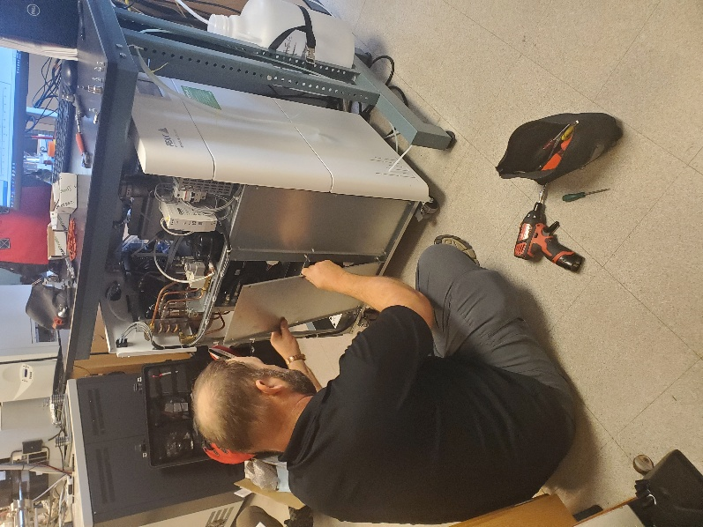

Unplug white plugs (4)

Unscrew black hoses on left (4). Wear gloves, sheet metal is sharp

Remove compressors, 2 at a time (total of 4)

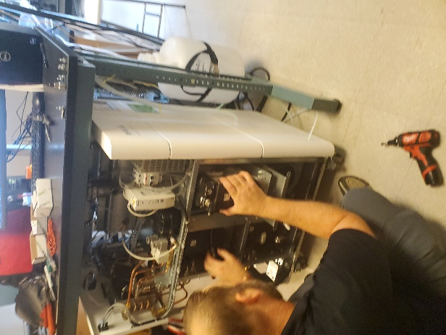

Remove top black covers on compressors. Screws are tight (8 on each top)

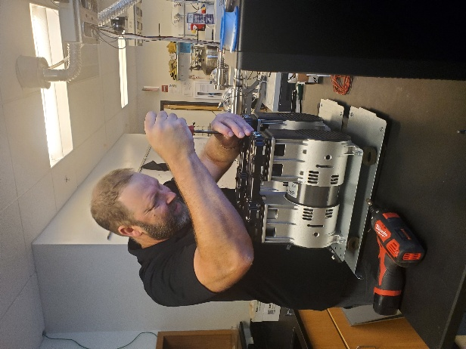

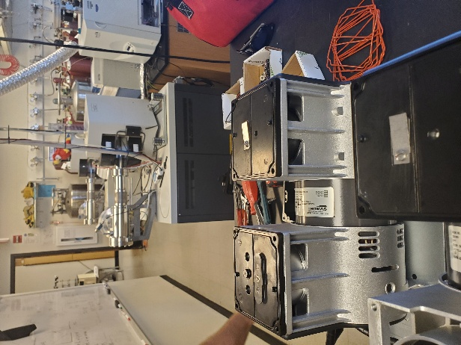

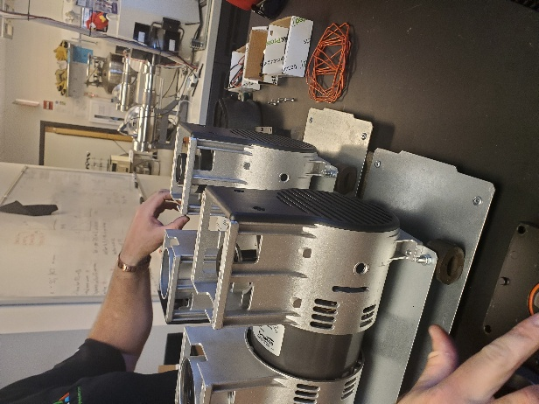

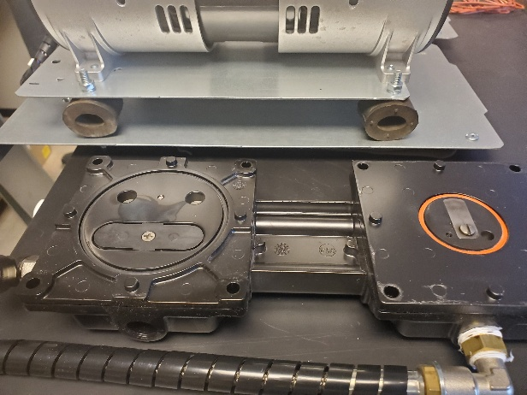

Unscrew shafts (black and silver)

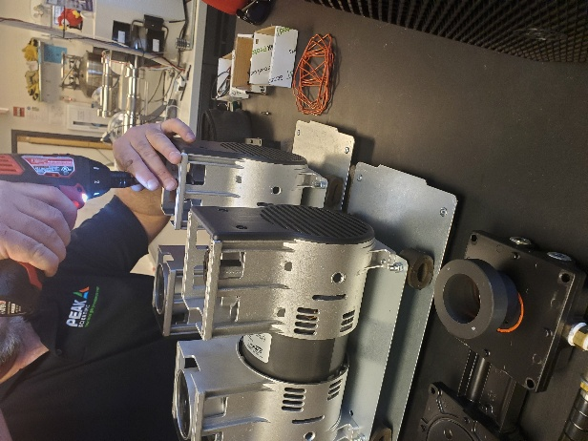

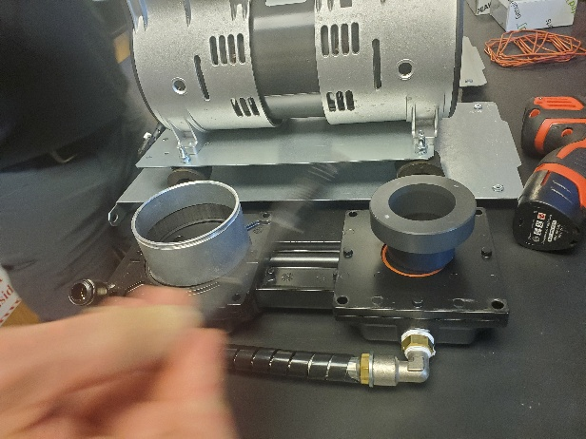

Scrub inside of shafts (one silver, one black) with wire brush

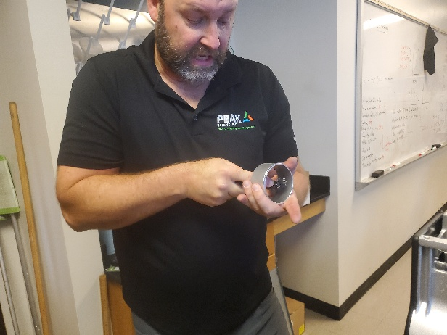

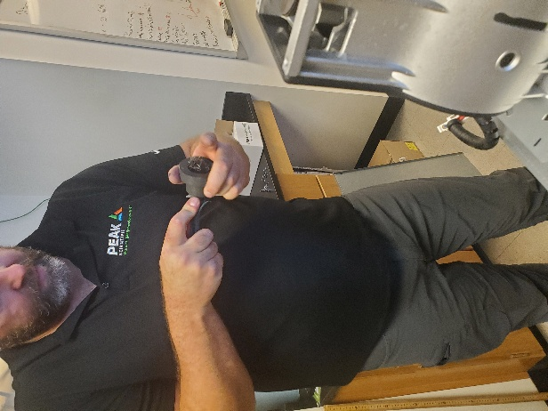

Unscrew piston bolt heads (2 on each). Replace black o ring. If use new bolts Scrub off lock tight first. Be sure to lone up bolt with hole on low pressure side (small black). Push down on high pressure side (silver) to get low pressure side to come up for easier access.

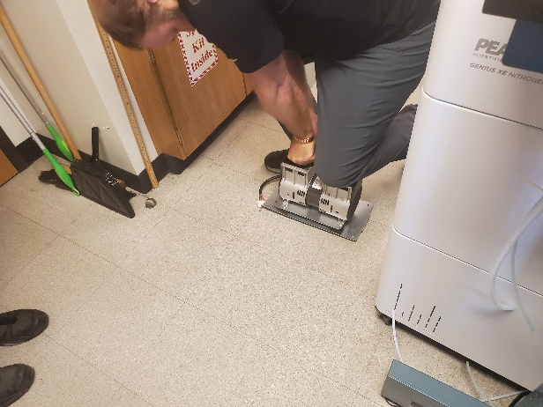

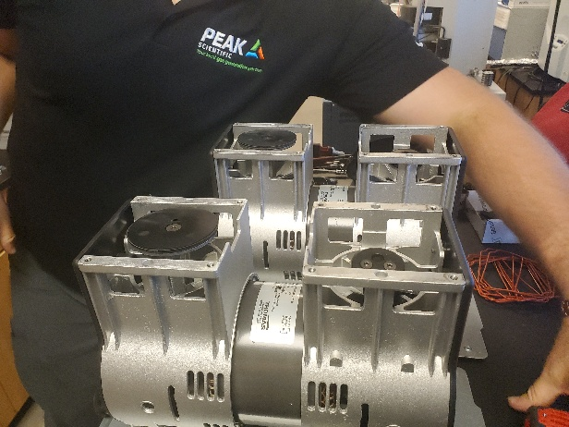

Pop open plate with hammer and screw driver with to access o ring underneath (oddly shaped orange o ring).

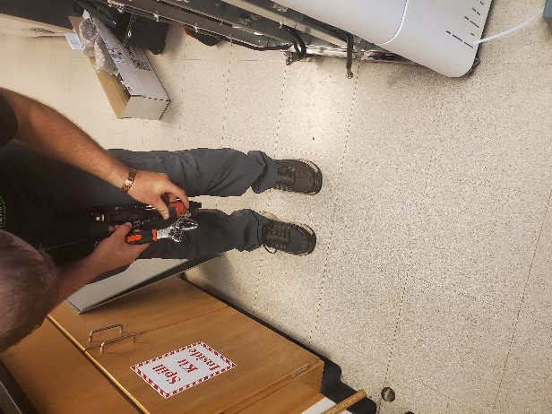

Replace silver flapper valves on inside of plates just removed. The flapper valves are different on each side (high and low pressure sides)

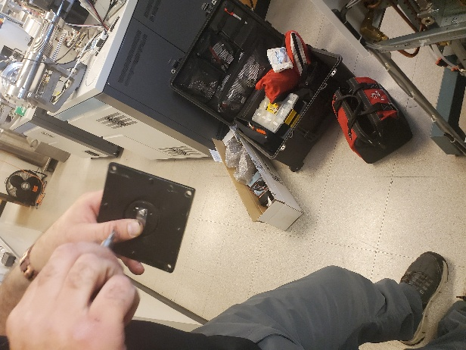

Replace o rings (black and orange) on black plates



Replace plates on top. Replace oddly shaped orange o rings

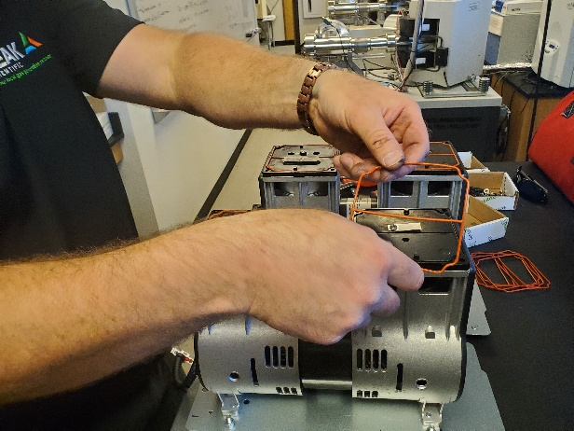

Replace lid. There should be no gap if lined up correctly

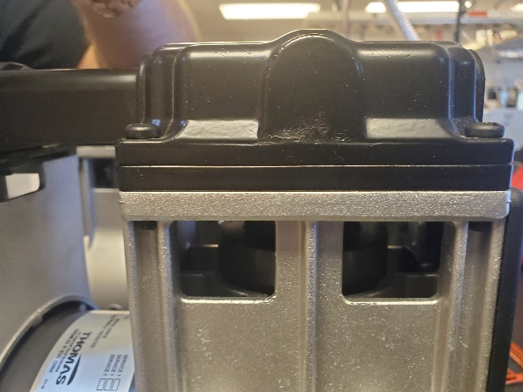

Slide compressors back in. Line up notch in back with slit. This can be difficult

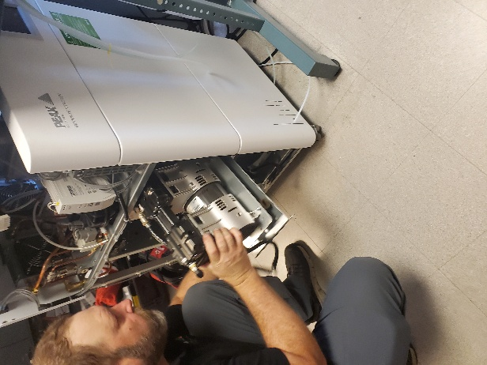

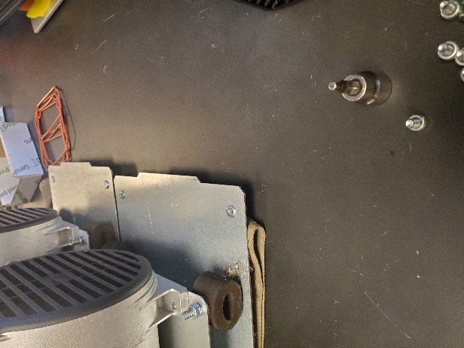

Plug in white plugs. Reconnect black hoses

Replace battery. To access, remove nitrogen membranes (they last 5-10 years). Then remove plastic box. Replace battery. Don't touch circuit board. Probably not necessary to replace battery every year.

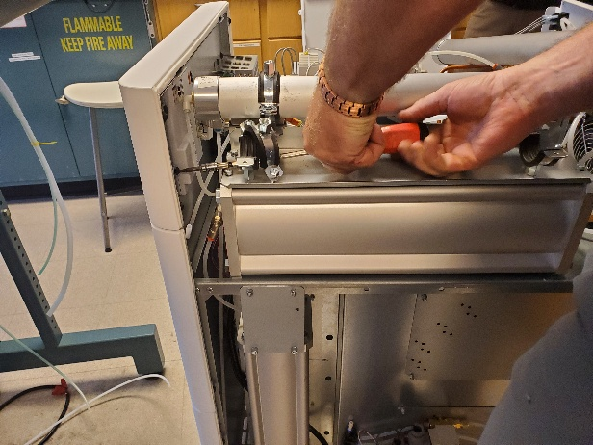

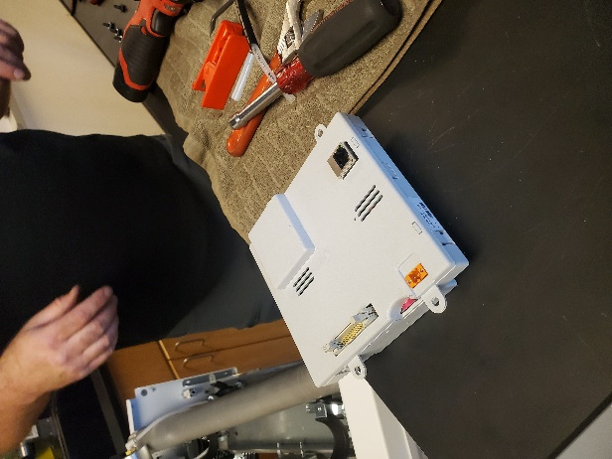

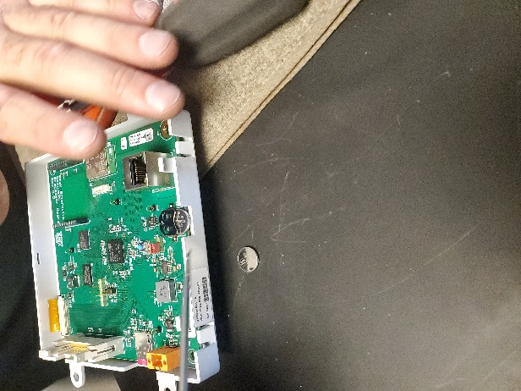

Turn red valve 90 degrees

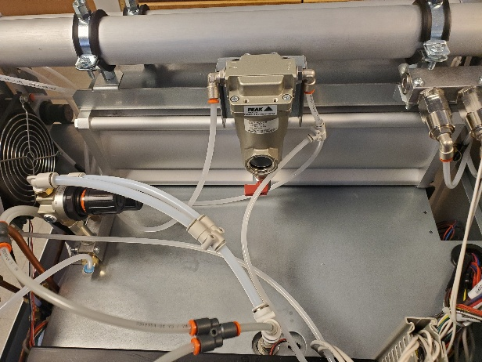

Test before putting panels back on. Plug in. Reconnect drain hose. Turn on..Set to 100 psi (analogue) should read 70-80 on digital red number.

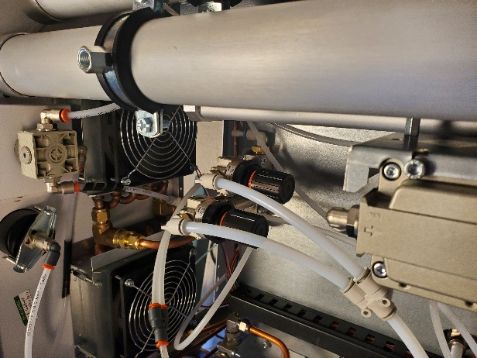

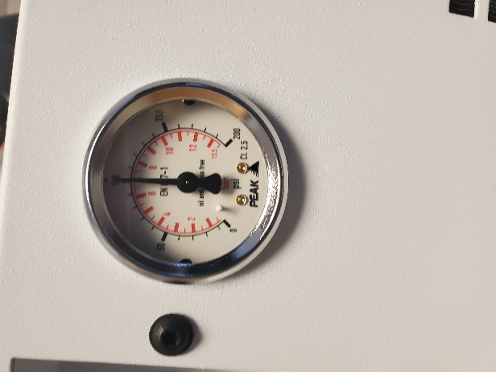

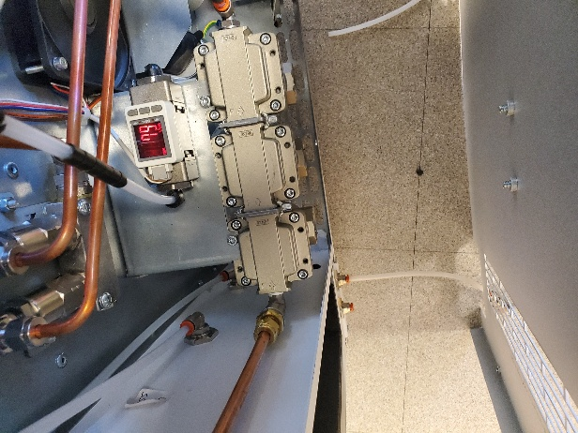

Need a pass code to reset timer. Passcode changes every time. Call to ask Dave for the code.

After testing, turn off, release pressure with red valve, Unplug, replace panels. Start with back panel. Then silver panels that cover compressors. Then side panels. Then top panel.

Plug in. Connect drain hose.

To reset timer, press lock image on screen and enter code. Push settings (gear image) to reset timer. Resets date to Jan after changing battery so reset date on screen.

